# Install Mobicip with HTTP/S proxy for allowed traffic.

Register Mobicip:

* **(Disposable)** Email: xxxxxxxxxxx@nwytg.net
* Password: xxxxxxxxxxxxxxxxx

Make 'AdminKnownLongPass':

* Password ([Random 20 chars](https://www.random.org/passwords/?num=1&len=20&format=html&rnd=new)): xxxxxxxxxxxxxxxxx

Make 'AdminByUSB':

* 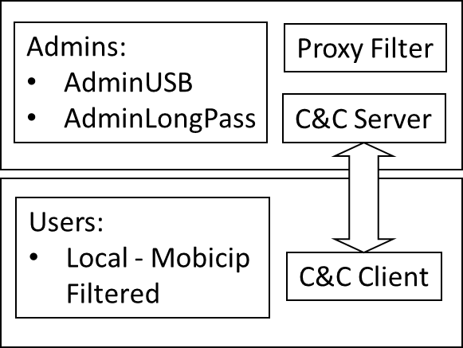[X] Make USB recovery

Make services (put in same folder):

* [V] Nssm Proxy service
  + Name: Yoni_ProxyFilter
  + Max log filezise – 104857600 (100MB)
* [V] Nssm C&C Service
  + Name: Yoni_CCServer
  + Max log filesize – 104857600 (100MB)

Make config file for services:

* [V] delete “config.json” and run one of the program to make simple config (with local paths)
* [V] set “PROXY_SERVICE_NAME” to proxy service name
* [V] set “ADMIN_USERNAME” to 'AdminUSB' username
* [V] Choose Ports
* [V] Choose block times
* [V] Using mapping and distinct log -> make proxy whitelist, also whitelist to Mobicip
* Folder permission

[V] Make Mobicip account and configure blockage:

* (Screen lock can be avoided)

[V] Set Mobicip to lock local user account.

Extra passwords\actions:

* Server: xxxxxxxxxxxxxxxxxxxxxx
* 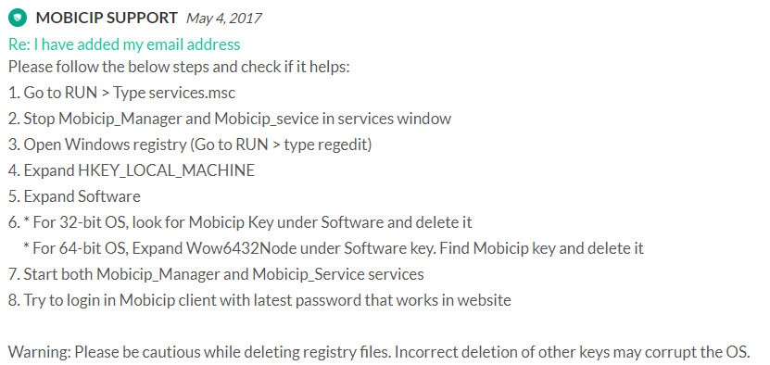GIT (Custom chain SSL) – Add certificate git config --global http.proxy http://127.0.0.1:9011

Local user C&C Client:

* [X] Make random password for Admin from C&C Client.
* [X] Lock for X time.